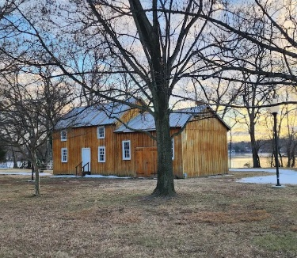
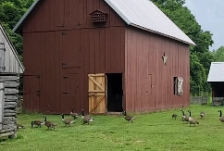
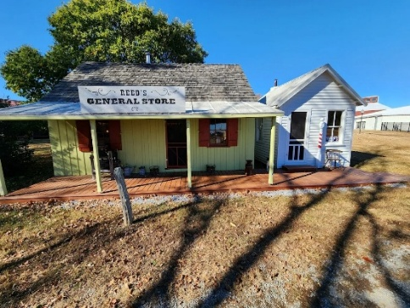
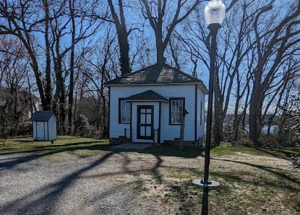
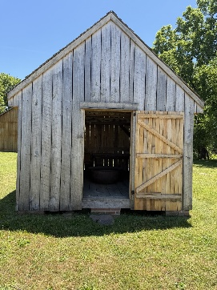
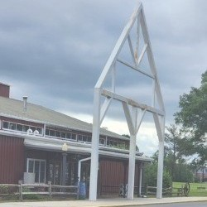
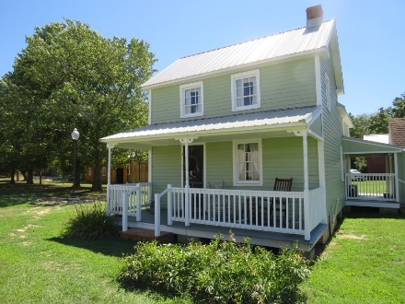
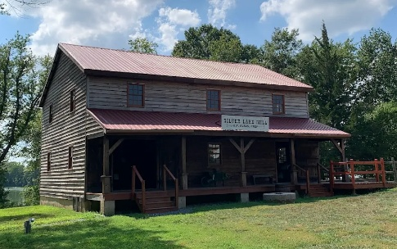
CLAIMED
CLAIMED
Schoolhouse
General Store
Front Entrance
Farmhouse
Barn
Barbershop
Smokehouse
A Farmer’s Christmas 2026
Village Buildings to Be Decorated

Blacksmith

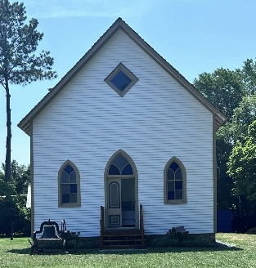
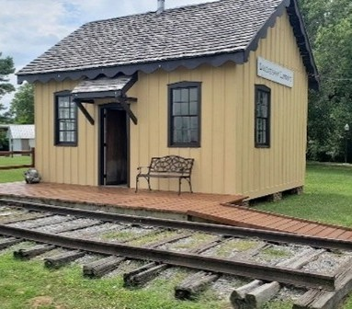
CLAIMED
CLAIMED
CLAIMED
CLAIMED
CLAIMED
CLAIMED
Church
Wheelwright
Train Station
Mill

